Health Cloud for Payers
Contents
Executive Summary 1
Challenges 2
Enter Health Cloud 3
Health Cloud Capabilities for Payers 3
Patient and Member Services 4
Members 4
Health Plan Professionals 4
Care Orchestration 5
Provider Network and Relationship Management 5
Utilization Management 6
Additional Capabilities 6
A Health Plan for Retirement 6
Commercial Sales 6
Provider Network Management 7
Use Case for Provider Engagement 7
Utilization Management 8
Use Case for Member Engagement 8
Care Management 9
Use Case for Care Management 9

Executive Summary
Health insurers face mounting pressure to improve member experiences, control medical costs, protect sensitive information, modernise fragmented systems, and meet evolving regulatory requirements. Salesforce Health Cloud provides an integrated platform to address these priorities by bringing member, provider, clinical, and operational data into a secure environment and enabling more personalised, efficient, and coordinated service delivery.
The platform supports the payer value chain through digital member and provider engagement, care orchestration, utilisation management, provider network management, commercial sales, and distribution management. Capabilities such as identity and benefits verification, appointment management, Member 360 views, care plans, prior authorisation workflows, document automation, consent management, virtual care, and analytics help health plans streamline processes while supporting whole-person, value-based care.
For Cumulus, Health Cloud offers a path to modernise operations without compromising care quality or compliance. By combining a unified data foundation with guided workflows, automation, portals, and Salesforce ecosystem products, the organisation can accelerate service resolution, reduce administrative effort, strengthen provider relationships, close care gaps, and deliver more equitable and responsive member outcomes at scale.

Challenges
In the highly competitive health insurance industry, there’s always a risk of becoming obsolete. Many payers are now facilitating and enabling better healthcare through shifts in payment models, analytics, and other mechanisms.
Ultimately, companies lag behind the general market in making transformational changes. To develop Cumulus’s business strategy and drive growth, the senior leadership team identifies the following core priorities.
Priority | Description
Improve member experience | Because consumers compare the health insurance experience with other industries, it’s critical to create an OmniChannel user experience driven by personalization and efficiency.
Decrease medical costs | Companies want to reduce its inflated medical costs without compromising the quality of care its members receive.
Ensure security of member information | With constantly changing technology, companies must assure airtight security and privacy of member information.
Improve existing systems and processes | Companies want to enable data-driven decision-making and sharing by integrating its disparate data sources in a secure cloud environment.
Comply with regulatory requirements | To maintain regulatory compliance, companies have implemented new software, but it still struggles to work with electronic health record (EHR) providers to make the data interoperable.

Enter Health Cloud
Built on the Salesforce Platform, Health Cloud is an integrated solution for delivering equitable, whole-person care from anywhere.
Here’s how Health Cloud benefits health Insurance companies and solves their core priorities.
- Manage affordable, high-quality coverage: Value-based care is an increasingly important delivery model in which providers are paid based on patient health outcomes. To support this model, Health Cloud provides tools for payers to manage affordable, data-driven, high-quality coverage for all members.
- Digitize user experiences: Health Cloud, in concert with Experience Cloud, offers OmniChannel member, provider, and partner experiences that enable health plans to deliver individualized, high-touch care at scale.
- Provide whole-person care from anywhere: Health Cloud equips payers with the tools to help improve health outcomes for all, particularly its most vulnerable member population. Health plans can target social determinants of health to improve equitable health outcomes. Further, virtual care capabilities enable health plans to connect members and providers virtually.
- Accelerate data and automation: Health Cloud unlocks the power of hyper-automation, guiding health plans to automate countless business processes. This results in unlocking productivity, accelerating time-to-market, and transforming user experiences.

Health Cloud Capabilities for Payers
Health Cloud has many features that—in tandem with other Salesforce products—power solutions for common healthcare industry scenarios.
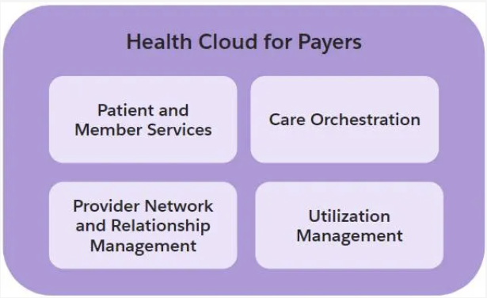

Patient and Member Services
These features focus on healthcare payer engagement with members. Increasingly, payers must understand member data, answer questions, and resolve concerns with speed, accuracy, and empathy. Using these features, payers can track and verify member health and information, deliver personalized service to members, and support their access to care.
Payers can use Contact Center for Health Cloud to digitize key customer service processes required to operate health insurance plans across all lines of business. This solution personalizes contact center experiences, such as caller validation, member relationship mapping, interaction tracking, and call wrap-up.

Members
- Provider Search: Search for healthcare providers by location, speciality and other factors.
- Provider Relationship Cards: View information about providers and their facilities and locations.
- Intelligent Appointment Management: Schedule appointments with providers at a preferred time and location via a member portal.

Health Plan Professionals
- Intelligent Appointment Management: Book appointments for members.
- Benefits Verification: Determine the benefits that are available to members by connecting to external services that contain coverage information.
- Identity Verification: Verify a member or their representative’s identity when they call the contact centre.
- Advance Patient Card: View summary of a member’s important details at glance.
- Enhance Timeline: View a member’s health care events in chronological order, and filter by event type.
- Life Events: Capture events and milestones in a member’s life.
- Assessments: Create questionnaires to gather comprehensive data and conduct them with members over the phone or in person.
- Unified Health Scoring: View member health profiles and take contextual actions.
- Intelligent Document Automation: Upload and manage patient forms. Route forms automatically to the right queue for faster review and processing.
- Consent Management: Capture member consent so that payer staff can proceed with a plan action.
- Care Programs: View which care programs members are enrolled in.

Care Orchestration
Care Orchestration consists of care management and care coordination, and it focuses on the actual delivery of care to members. The feature also orchestrates when, where, and how the members receive the care.
- Integrated Care Management: Create a comprehensive care plan using guided flow to track members’ problems, goals, and intervention recommendations.
- Care Teams: View and manage the team members who deliver the care to the member.
- Care Gaps: Identify and track gaps in a member’s care and deliver specific care to cover those gaps.
- Virtual Care: Schedule video visits between providers and members.
- Social Determinants: Capture critical social and environmental factors that impact a member.
- Remote Exception Monitoring: Streamline the member device registration process and then visualise the data to monitor health events over time.
- Medication Management: Manage the medication regimen of members.
- Medication Review: Review and optimise a member’s medication list.
- Medication Reconciliation: Reconcile member medications and add relevant recommendations during transitions of care.
- Medication Therapy Management: Optimise a member’s medication for the best possible therapeutic outcomes and prevent expensive drug-related problems.

Provider Network and Relationship Management
Manage a provider network from recruitment, credentialing, contracting, appointment, onboarding, and beyond.
- Provider Recruitment: Identify and recruit prospective providers.
- Provider Credentials: Collect, review and verify provider credentials.
- Provider Contract & Network Management: Create, negotiate and sign provider contracts.
- Network Participations: Set up new providers to successfully participate in a network.
Provider relationship features give users a full view of their provider network, including facilities, licenses, education, work history, references, and professional liability coverage.

Utilization Management
Ensures patients receive the right care, at the right time, and in the right setting. Employ Utilization Management for utilization reviews, such as prior authorization and service requests, to better manage the cost of care.
- Customised guided flows (OmniScripts): Perform a need assessment to determine whether an authorisation request is required for a specific medical service.
- Guided pre-defined flows: Submit and track requests through electronic prior electronic authorisation (ePA)
- Benefits Verification: Verify eligibility and benefits upfront to eliminate the primary cause of administrative denials.

Additional Capabilities
Distribution Management
Track producer data for licenses, education, training, and more. Distribution Management provides guided workflows to manage the entire producer lifecycle. Health plans can efficiently qualify and appoint new selling partners and then use analytics tools to closely manage and monitor broker performance.
Commercial Sales
Build and sell benefits to customers across all markets. Health plans can launch a modern rate, quote, and apply shopping experience across all lines of business, including individual, group, Medicare, and ancillary.
To support these processes, the solution comes with a full product catalog and rating engine. Prebuilt business processes enable prospective members to shop, compare, and select plans with ease.

A Health Plan for Retirement

Commercial Sales
Commercial Sales helps health plans deliver a modern rate, quote, and shopping experience. It provides tailored solutions for all lines of health insurance, including individual, family, group, Medicare, and ancillary plans like vision and dental.

To deliver a complete shop-and-enrol experience for prospective members, companies use several Salesforce tools alongside Health Cloud, including Experience Cloud, Salesforce Industries (SFI), and Marketing Cloud.

Provider Network Management
Companies manage and empower brokers with a distribution management system; it also sets up a provider network system to manage all key stages of the payer-provider relationship.
Provider Network Management enables organizations to find and manage their provider partners, including recruitment, credentialing, contracting, appointment, onboarding, and servicing providers with a network.
At the center of the solution is the health care provider—the individual or organization licensed to provide the actual health care diagnosis and treatment services to members. A provider may be an individual professional such as a doctor or a large health facility organization such as a hospital. When treating insured patients, health care providers receive their payments for services from health plans.

Use Case for Provider Engagement
Using CRM Analytics in concert with Health Cloud, the marketing and recruiting team at Cumulus identifies Dr. Bass as a high-value prospect. Dr. Bass is particularly valuable as she fills in important geographic and speciality gaps in its existing provider network. To express interest, Cumulus sends a personalized email that invites Dr. Bass to fill out a provider registration form.
Dr. Bass fills the form and completes the application on Cumulus’s dedicated provider portal.
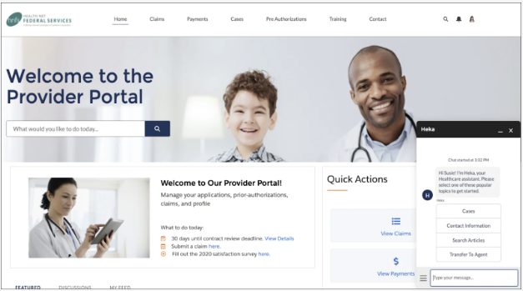
From there, the credentialing specialist at Cumulus takes the reins using Health Cloud and Flow Orchestration tools to verify Dr. Bass’s professional qualifications.
Once the credentialing stage is complete, it’s time to discuss and negotiate the plan’s terms. This stage consists of hashing out agreements about prior authorizations, reimbursements, claims processes, rates, and more. Robust digital contracting tools and workflows plus predesigned templates, versioning, approvals, and e-signature integrations make everything fast and efficient.
After signing the contract, Dr. Bass initiates her onboarding experience with guided workflows and automation from Health Cloud, which smooths her path. Over time, she and the office staff stay connected to Cumulus through ongoing outreach campaigns, portals, and personalized provider service.

Utilization Management
Utilization Management enables Health Insurance Companies to perform core utilization review functions, such as prior authorization and service requests, so companies can better manage its member’s cost of care. This process helps both members and providers to ensure the right care is delivered at the right time.

Use Case for Member Engagement
Over the last couple of years, the pain has prevented Milly from enjoying her favorite outdoor activities. One of her friends who was suffering from a similar hip condition just had a successful surgery. Milly gets curious and decides to look into a hip operation for herself.
She searches the Cumulus provider network and sets up an appointment to meet Dr. Bass, the orthopedic surgeon. After a consultation, Dr. Bass concludes that Milly should hold off on surgery at this stage and try physical therapy.
Using the provider portal, Dr. Bass’s office manager confirms Milly’s benefits and submits a prior authorization request for physical therapy visits.
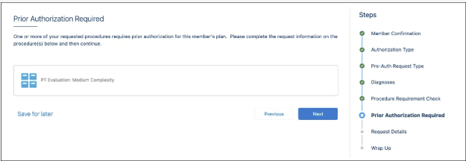
After the office manager enters additional information about the request, authorization for physical therapy visits is automatically approved. Dr. Bass downloads the authorization summary and schedules Milly’s physical therapy treatment without delay.
When Milly seeks a second opinion outside of her network, tools such as Intelligent Document Automation and Intelligent Form Reader automate all stages of the process.
If a service request can’t be automatically approved, Health Cloud routes it to the clinical team for review. Everything the reviewer needs to assess the request is right there in a single view. In Milly’s case, Dr. Bass had documented that surgery wasn’t a medical necessity because Milly hadn’t tried a conservative treatment yet.

Care Management
Increasingly, members expect health plans to go beyond determining service authorizations and more actively participate in the orchestration of their care.
Care Management enables health plans to establish a care plan for a member's specific condition or risk factors. This includes developing and monitoring health goals and care plans, monitoring health states, member outreach, scheduling, claims review, and program eligibility.

Use Case for Care Management
Charles is a recent retiree who also has a Medicare plan with Cumulus. He’s working to better control his diabetes. Based on risk stratification metrics, Charles recently moved from low risk to high risk.
Health Cloud assigns Charles to Cara Candle, a care manager who specializes in managing high-risk diabetic members.
Before meeting with Charles for a screening, Cara reviews the relevant details from his member record. Thanks to Member 360, she can access all information about Charles in a single view. From the member timeline, she sees that Charles has never been enrolled in a formal care program.
Cara consults with Charles and he provides consent to enroll. Next, she takes an assessment and personalizes the care plan according to his needs and characteristics. The assessment is held in Salesforce and provides a dynamic framework to ask relevant, targeted questions, and identify any barriers to a successful treatment.
Based on the results, Cara creates a care plan for Charles. She can review and update the plan as needed. After that, Charles receives personalized automated member outreach, which delivers education and reminders at the right time. If he doesn’t respond, Cara receives a notification and can follow up.
Charles takes full advantage of the care plan, regularly visiting his member portal to learn all about his care, benefits, and sources for diabetes information and data. His wife, Milly, is assigned insulin intake education, just in case Charles can’t inject himself. They can always use the member chat feature to ask questions and get real-time answers.

